**Assignment 5**

1.

Server code:

#include <stdio.h>

#include <stdlib.h>

#include <string.h>

#include <unistd.h>

#include <arpa/inet.h>

unsigned long long factorial(int n)

{

   unsigned long long result = 1;

   for (int i = 2; i <= n; i++)

   {

      result *= i;

   }

   return result;

}

int main()

{

   int server_fd, new_socket;

   struct sockaddr_in address;

   int addrlen = sizeof(address);

   int num;

   unsigned long long fact_result;

   server_fd = socket(AF_INET, SOCK_STREAM, 0);

   address.sin_family = AF_INET;

   address.sin_addr.s_addr = INADDR_ANY;

   address.sin_port = htons(8080);

   bind(server_fd, (struct sockaddr *)&address, sizeof(address));

   listen(server_fd, 3);

   new_socket = accept(server_fd, (struct sockaddr *)&address, (socklen_t *)&addrlen);

   read(new_socket, &num, sizeof(num));

   fact_result = factorial(num);

   write(new_socket, &fact_result, sizeof(fact_result));

   close(new_socket);

   close(server_fd);

   return 0;

}

Client Code:

#include <stdio.h>

#include <stdlib.h>

#include <string.h>

#include <unistd.h>

#include <arpa/inet.h>

int main()

{

   int sock = 0;

   struct sockaddr_in serv_addr;

   int num;

   unsigned long long fact_result;

   sock = socket(AF_INET, SOCK_STREAM, 0);

   serv_addr.sin_family = AF_INET;

   serv_addr.sin_port = htons(8080);

   inet_pton(AF_INET, "127.0.0.1", &serv_addr.sin_addr);

   connect(sock, (struct sockaddr *)&serv_addr, sizeof(serv_addr));

   printf("Enter an integer: ");

   scanf("%d", &num);

   write(sock, &num, sizeof(num));

   read(sock, &fact_result, sizeof(fact_result));

   printf("Factorial of %d is %llu\n", num, fact_result);

   close(sock);

   return 0;

}

Output:

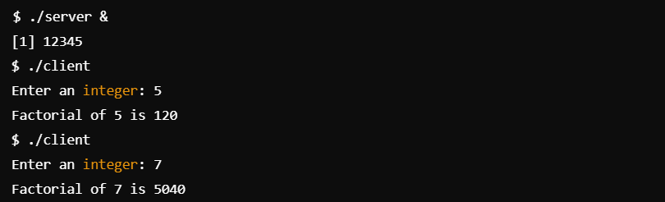

2.

Mapper.c

#include <stdio.h>

#include <stdlib.h>

#include <dirent.h>

#include <sys/stat.h>

#include <pwd.h>

#include <unistd.h>

int main()

{

   struct dirent *entry;

   struct stat file_stat;

   DIR *dp = opendir(".");

   if (dp == NULL)

   {

      perror("opendir");

      return EXIT_FAILURE;

   }

   while ((entry = readdir(dp)))

   {

      if (entry->d_type == DT_REG)

      {

         if (stat(entry->d_name, &file_stat) == 0)

         {

            struct passwd *pw = getpwuid(file_stat.st_uid);

            if (pw)

            {

               printf("%ld\t%s\n", file_stat.st_size, pw->pw_name);

            }

         }

      }

   }

   closedir(dp);

   return EXIT_SUCCESS;

}

Reducer.c

#include <stdio.h>

#include <stdlib.h>

#include <string.h>

#define MAX_LINE_LENGTH 256

int main()

{

   char line[MAX_LINE_LENGTH];

   long max_size = 0;

   char owners[MAX_LINE_LENGTH][MAX_LINE_LENGTH];

   int owner_count = 0;

   long file_size;

   char owner[MAX_LINE_LENGTH];

   while (fgets(line, sizeof(line), stdin))

   {

      sscanf(line, "%ld\t%s", &file_size, owner);

      if (file_size > max_size)

      {

         max_size = file_size;

         owner_count = 0;

         strcpy(owners[owner_count++], owner);

      }

      else if (file_size == max_size)

      {

         int found = 0;

         for (int i = 0; i < owner_count; i++)

         {

            if (strcmp(owners[i], owner) == 0)

            {

               found = 1;

               break;

            }

         }

         if (!found)

         {

            strcpy(owners[owner_count++], owner);

         }

      }

   }

   for (int i = 0; i < owner_count; i++)

   {

      printf("%s\n", owners[i]);

   }

   return EXIT_SUCCESS;

}

Output:

